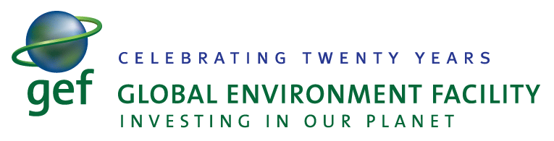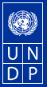

Sixth GEF Biennial International Waters Conference (IWC6)
Dubrovnik, Croatia
17-20 October 2011

This note contains information related to the organization of the Sixth Global Environment Facility Biennial International Waters Conference, organized by UNDP & partners on behalf of the GEF International Waters project portfolio, in the Mediterranean region in 2011.

The Global Environment Facility (GEF) – www.thegef.org, unites 182 member governments - in partnership with international institutions, nongovernmental organizations, and the private sector — to address global environmental issues. An independent financial organization, the GEF provides grants to developing countries and countries with economies in transition for projects related to biodiversity, climate change, international waters, land degradation, the ozone layer, and persistent organic pollutants. These projects benefit the global environment, linking local, national, and global environmental challenges and promoting sustainable livelihoods

The GEF International Waters (IW) focal area targets transboundary water systems, such as shared river basins, lakes, groundwater and large marine ecosystems. The IW portfolio comprises to date 170 projects and consists of some US$1.2 billion of GEF grants invested in 149 different countries globally. This investment has leveraged approximately US$5 billion in co-financing. By all accounts and evaluations, since the inception of the GEF in 1991, the IW portfolio has delivered substantive results and replicable experiences to be scaled-up and mainstreamed globally.

The GEF Biennial International Waters Conference (IWC) is a signature learning event for the GEF IW focal area. Since 2000, the IWC has progressed from a portfolio-wide stock-taking exercise into an active training and experience-sharing event. IWCs convene on average 300 participants from about 70 projects, 80 countries and the GEF agencies to share practical experience, apply evolving policies and procedures, address emerging priorities and improve overall project performance.

The IWC6 will feature an innovation marketplace (exhibit area), extensive opportunities for focused learning on scientific and technical innovations, interactive training for project managers and country representatives, interaction with the GEF Secretariat, GEF agencies and several partner institutions working on International Waters projects. The Conference will also feature participant-directed workshops and round-table discussion. The conference will highlight GEF IW projects contributions to ecosystem-based management of the shared water bodies and sustainable implementation of Millennium Development Goals (MDG) and targets.

During the Conference, the 20th anniversary of GEF will be observed. This anniversary will mark a major milestone for the world’s largest actor catalyzing international cooperation over one of the world’s most precious resources - water. Achievements and results from the IW project portfolio since the creation of GEF in 1991 will be showcased.

In the past 20 years, the GEF and its implementing agencies have enjoyed working together with a wide array of different partners from both the private and public sectors in the implementation of the GEF IW portfolio and also in the organization of the previous five IWCs. We strongly hope that in the coming year, the cooperation will be further fostered and there will be more partners attracted to this commemorative Conference.

Information contained in this memo will hopefully initiate a discussion on possible partnership with your organization in implementing this signature event. The IWC6 offers a chance to engage a major cross-section of the actors engaged in managing an essential resource that has, in most cases, only international solutions. Working closely in partnership with multilateral, bilateral and private sector actors is vital to the success of GEF IW portfolio.

GEF and UNDP are looking for the opportunity to discuss your organization potential support and participation in the Conference. There are different opportunities and possibilities to contribute to the Conference success and showcase your organization profile and portfolio relevant to the GEF agenda in general and in particular to the topic of the Conference. We invite you to dialog on this with:

Dr. Vladimir Mamaev,
GEF IW Regional Technical Advisor
UNDP Bratislava Regional Centre
Tel: +421 2 59337 267
vladimir.mamaev@undp.org

Cc: info@iwlearn.org

For more information on the five previous IWC’s, please visit http://www.iwlearn.net/iwc2009, /iwc2007, /iwc2005, /iwc2002 and /iwc2000.

